Standard Operating Procedure
Dumper Operator (Transportation)


ODISHA MINING CORPORATION LTD.
KODINGAMALI BAUXITE MINE
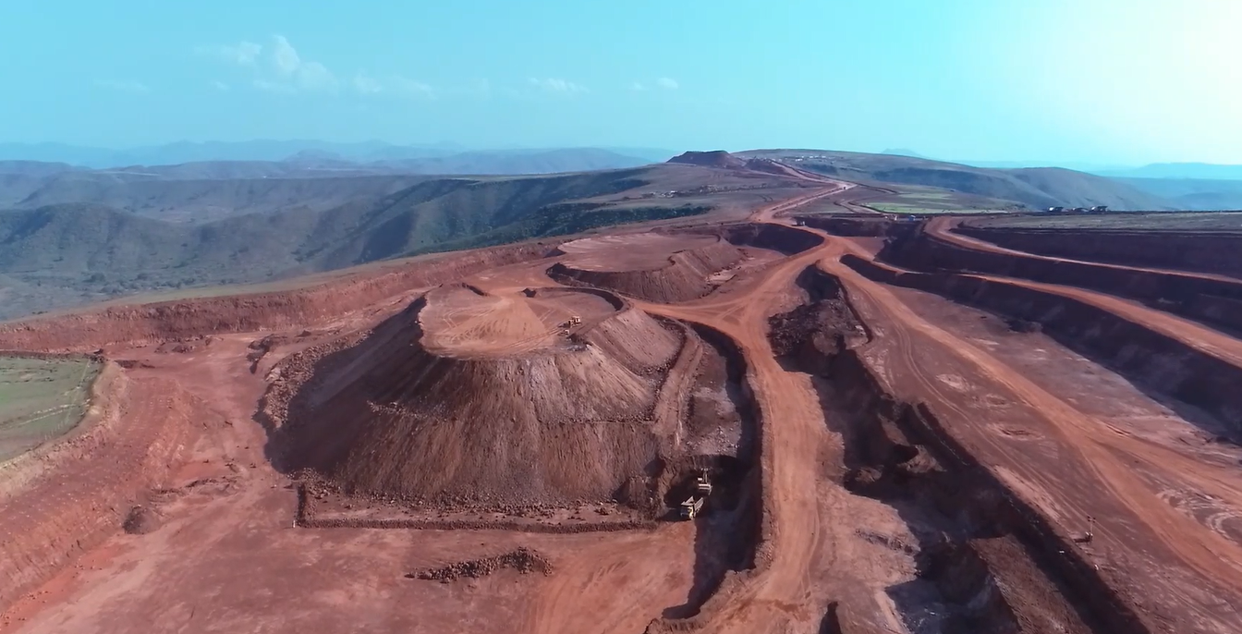

Authorized By
- Operator has to wear all safety gadgets.
- Operator has to conducted full check-up of safety devices & others parameters of his allocated dumper and he is determined that it is functioning in order / it is in safe working / serviceable condition.

I. Safety devices like:-
- Brakes
- Head Light
- Horns
- Emergency Brakes
- Blinkers
- Level of Fuel/Quantity of Fuel
- Level of Lubricant
- Level of hydraulic Transmission
- Level/Quantity of Brake oil
- Level of Coolant & its Quality
- Fan belt & dynamo
- All pressure parameter
- All Temperature parameter
- Tyre & tyre condition
- Rear view mirror

- Operators are responsible to be cautioned for any unsafe condition while he is on driving e.g.
- Poorly placed signs
- Confusing signs
- Over crowed signs
- Missing signs
- Out of date signs
- Road way problems
- Problem with vehicle

- Operator follows speed limit (permissible to mines /mines premises –normally it is kept 15-20 kmh).
- Whenever sight is intersected, Operator uses horns to alert the traffic coming from other site.
- While negotiating curve he keeps los speed and select a turning radius commensurate with the speed.
- While in operation Operator ensure that gear is selected according to load, gradient and speed.
- While Operator operates in down gradient, he keeps the Dumper in low gear range and keeps applying retards to avoid engine over race and consequent damage.
- While Operator backing up the vehicle ,he ensure that back up signal is working and that back passage is clear of men & object
- Belt up in the back.
- Take special care about the children , Senior Citizen and Pedestrian while driving outside of mines/public road/private road/City
- Always observe and anticipate other road users
- Keep your standard distance gap
- Always wear helmet / & seal belt
- While driving, he follows the traffic signals/rules.
- While placing the vehicle for taking load (minerals/materials), he will ensure that vehicle is placed in proper reach (safe reach) of loading equipment, he follows proper signals (indications) of loading operator/spot supervisor.
- He will ensure that he does not delay deliberately after receiving signal to proceed after giving desired load by loading operator.
- While placing vehicle to unload minerals/materials, he will ensure that rear wheel never cross the marked safe zone and he gives alerting signal (horns) before unloading. However, he may take help of spot supervisor/spotter if available.

